**ONLINE MESS BILLING SYSTEM**



**Session 2023 - 2027**

**Submitted by:**

Hania Arshad        2023-CS-13

**Supervised by:**

Sir Awais Hassan

**Course:**

CSC-102 Programming Fundamentals

Department of Computer Science

**University of Engineering and Technology**

**Lahore Pakistan**

**Contents**

ShortDescription of project: 3

1. Efficient Attendance Management 3

2. Convenience for Users 3

3. Fraud Prevention 3

4. Automated Billing 3

5. Record Keeping 3

6. Reduced Queues and Wait Times 3

7. Customization 3

8. Notifications 3

9. Feedback Mechanism 3

10. Cost Savings 3

Users of Application (minimum 2 users for project) 3

1.Customers or clients 3

2.Admins 3

Functional Requirements 4

ADMIN: 4

USER 4

Wireframes 5

Login page 5

Home page for admin 5

Home page for user 5

Bill calculation(checked by the user) 6

Available meals (checked by the user) 6

Feedbacks 7

List of Meals 7

# **ShortDescription of project**:

An online mess billing system is indeed a great solution to address the challenges faced in hostels or hotels with crowded mess areas. Here are some of the benefits and features of such a system:

1**. Efficient Attendance Management:** Hostellites can mark their attendance online, saving time and effort. Mess managers can access real-time attendance records, reducing the chances of fraud.

**2. Convenience for Users**: Hostellites can mark their attendance remotely through a mobile app or a web portal. Users can check their attendance status and meal history online.

**3. Fraud Prevention**: The system can implement security features to prevent fraud, such as unique logins and verification methods. It can also track unusual attendance patterns and alert administrators to potential issues.

**4. Automated Billing**: The system can calculate bills automatically based on the user's meal attendance and the meal plan they've subscribed to. Users can view their bills and payment history online.

**5. Record Keeping**: All attendance and billing records are stored electronically, making it easier to track and manage data. Mess managers can generate reports for audits and analysis.

**6. Reduced Queues and Wait Times**: With online attendance marking, there is less congestion and waiting in the mess area.

**7. Customization**: The system can be customized to accommodate different meal plans and pricing structures. It can also integrate with existing hostel or hotel management software.

**8. Notifications**: Users can receive notifications for important updates, such as bill generation and payment deadlines.

**9. Feedback Mechanism**: Users can provide feedback on the quality of meals and service, helping the management improve the mess.

**10. Cost Savings**: The system can reduce the need for physical record-keeping and manual data entry, saving time and resources.

# **Users of Application (minimum 2 users for project)**

**1.Customers or clients**: For a mess billing system, the end-users who purchase or use the product are considered the main users called as customers or clients

**2.Admins**: Who specifically control what the clients or Employees will access the meal through online attendance system.

# **Functional Requirements**

|  |  |  |
| --- | --- | --- |
| **ADMIN:** | 1.Add products | Products could be added |
|  | 2.Apply discount | Discount is applied on the basis of the demand.the lower the demand, the higher the discount. |
|  | 3.Add price | Price of the meal will be set on the basis of quantity. |
|  | 4.update meals | New meals could be added through this command |
|  | 5.delete meals | Unavailable meals could be deleted. |
|  | 6.customers | The list of customers could be checked. |
|  | 7.Billing system record | Record of the bills could be calculated on monthly basis as well as on daily basis. |
|  | 8.Attendance marking | Attendance of customers will be marked on daily basis which will show that how often a person has visited the mess. |

|  |  |  |
| --- | --- | --- |
| **USER:** | 1.See meals | a customer could review the prices of the products. |
|  | 2.see bills | bills could be seen on daily basis and on monthly basis |
|  | 3.Give feedback | Customer can give feedback about a particular product. |
|  | 4.online attendance | Online attendance could be marked by the customer. |

# **Wireframes**

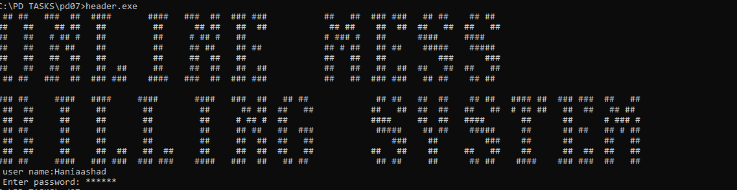

## Login page

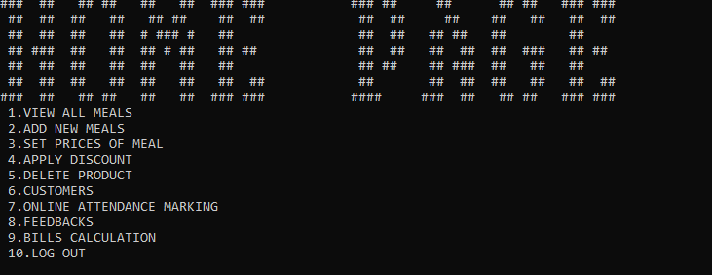

## Home page for admin

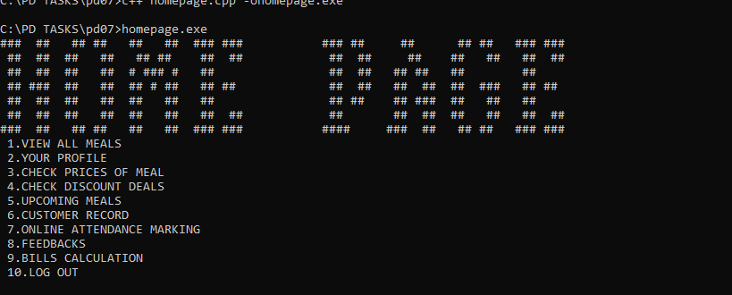

## Home page for user

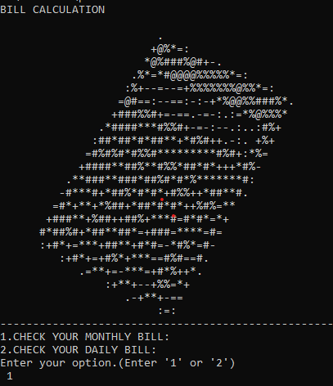

## Bill calculation (checked by the user)

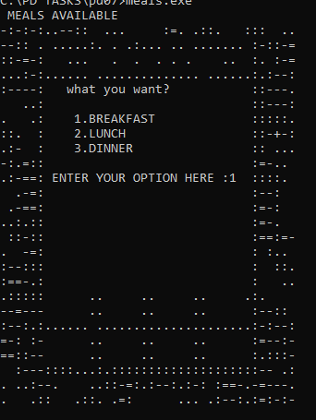

## Available meals (checked by the user)

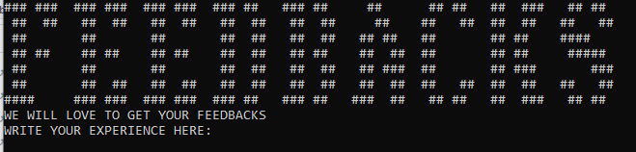

## Feedbacks

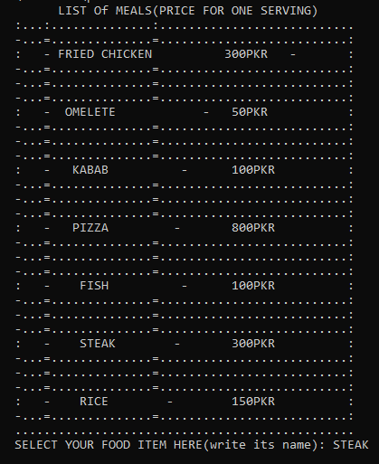

## List of Meals